Preparing your submission to Advancing Scholarship and Research in Higher Education

Jane Fantail
Flocknest University,
jane@flocknest.ac.nz

Jim Godwit
Roving Researcher
jim@godwitsflight.org

Keywords
Submission guidelines, formatting, word limits

Key contributions/Pathways to collaboration
- Key contributions relate to articles submitted under the Research Complete category; they should address what is already known about the topic, what the article adds, and implications for research and practice.
- Pathways to collaboration relate to articles submitted under the Research in Progress category; they should address what has already been achieved, how others can build on the research presented, and how current and future work might be integrated.
- Use 3 to 6 bullet points.

Abstract
This document illustrates ASRHE formatting and provides formatting instructions for all ASRHE submissions. Your abstract should be between 150 and 250 words.

Structure
Please ensure that your submission is a complete and coherent piece of work whatever structural or format choices you make. All submissions require a primary article text document with a title, author details, keywords, key contributions, or pathways to collaboration, an abstract, and references. Please include author details in support of our non-blind peer review process.

For traditional articles, your submission will comprise only this text document. For non-traditional articles additional files, text and/or multimedia, may be supplied. It is important that you explain in your primary article text document how the reader should approach additional files.

The submission process asks you to select the article component for each file that you upload (you can submit multiple files which are uploaded one-by-one). Select ‘Article Text’ for your primary submission document. For non-traditional submissions, additional files may be submitted. Select ‘Article Video’ for video and animation files. Select ‘Article Audio’ for audio files. Select ‘Article Image’ for image files or artwork. You should choose the ‘Article Other’ option for other common presentation file formats such as Microsoft PowerPoint or Adobe Acrobat.

Word and file size limits
For traditional articles the body should be between 3,500 and 5,000 words. The abstract, tables, figure captions, and references are in addition to this word limit.

For non-traditional articles, we offer the following guidance. Videos and/or animations should not exceed 10 minutes in length and should be supplied in mp4 format. We encourage you to consider accessibility including the use of closed captions. Audio files should not exceed 30 minutes in length and should be in mp3 format. Image files should not exceed 100Mb in size and we encourage you to consider resolution should readers decide to print images; tiff and jpeg formats are preferred. Preferred presentation file formats are pdf, pptx and odp. Files that cannot be opened and poor-quality files may be rejected without review.

If you are considering making a non-traditional submission and would like additional guidance, please contact editors@asrhe.org to seek advice.

Style guidelines
Please use UK spelling style consistently in all text submissions. Please use single quotation marks, except where ‘a quotation is “within” a quotation’. Please note that long quotations should be indented without quotation marks. For example, a long quotation from an interview might look like this.
xxxxxxxxxxxxxxxxxxxxxxxxxxxxxxxxxxxxxxxxxxxxxxxxxxxxxxxxxxxxxxxxxxxxxxxxxxxxxxxxxxxxxxxxxxxxxxxxxxxxxxxxxxxxxxxxxxxxxxxxxxxxxxxxxxxxxxxxxxxxxxxxxxxxxxxxxxxxxxxxxxxxxx. (Paul)
Text file formats and formatting
We accept text submissions in Microsoft Word, OpenOffice, or RTF file formats. This Microsoft Word example document conforms to our formatting guidelines. The document margins are 2.5 cm. Arial 12-point font is used throughout except for the title which is 14-point Arial. Only capitalize the first word in the title and section headings. Use 1.25 line spacing throughout. The main section headings are bold, and subheadings are italic. Please justify the abstract, the body paragraphs and the key contributions/pathways to collaboration. Blank lines can be used for spacing and please avoid underlining; use italics for emphasis. Please do not use footnotes. Figures, tables, and images should be inserted into the document in the most convenient place after they are first referred to in the text.

Figure 1

Pīwakawaka - The New Zealand Fantail

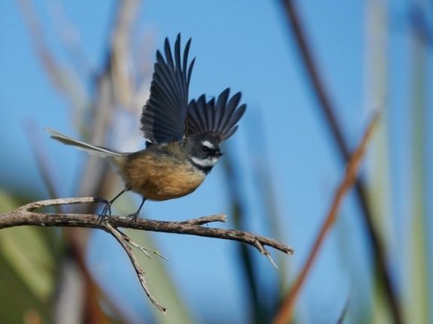

Note. Xxxxxxxxxxxxxxxxxxxxxxxxxxxxxxxxxxxxxxxxxxxxxxxxxxxx

There is no prescribed format for tables, but we recommend keeping them simple and similar to the example below. Here, we have used 12-point Arial bold for row and column headings and smaller, 10-point Arial font for the table body.

Table 1
Title of Table
 | Column 1 Heading | Column 2 Heading
Row 1 Heading | Data 1,1 | Data 1,2
Row 2 Heading | Data 1,2 | Data 2,2

References
Please use APA 7 style for all citations and references. Please include DOIs wherever possible. References are in 11-point Arial, block-justified, 1.25 line spacing, with 12 points of space (not a blank line) after every entry and a hanging indent of 8mm.

